2.11: Time (s) 0 2 4 6 8 10 12 14 16
Acceleration (m/s²) 0 1 2 2 3 1.5 1.5 0

a) The acceleration is not constant, but is approximately constant between the times 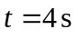 and 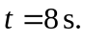

b)

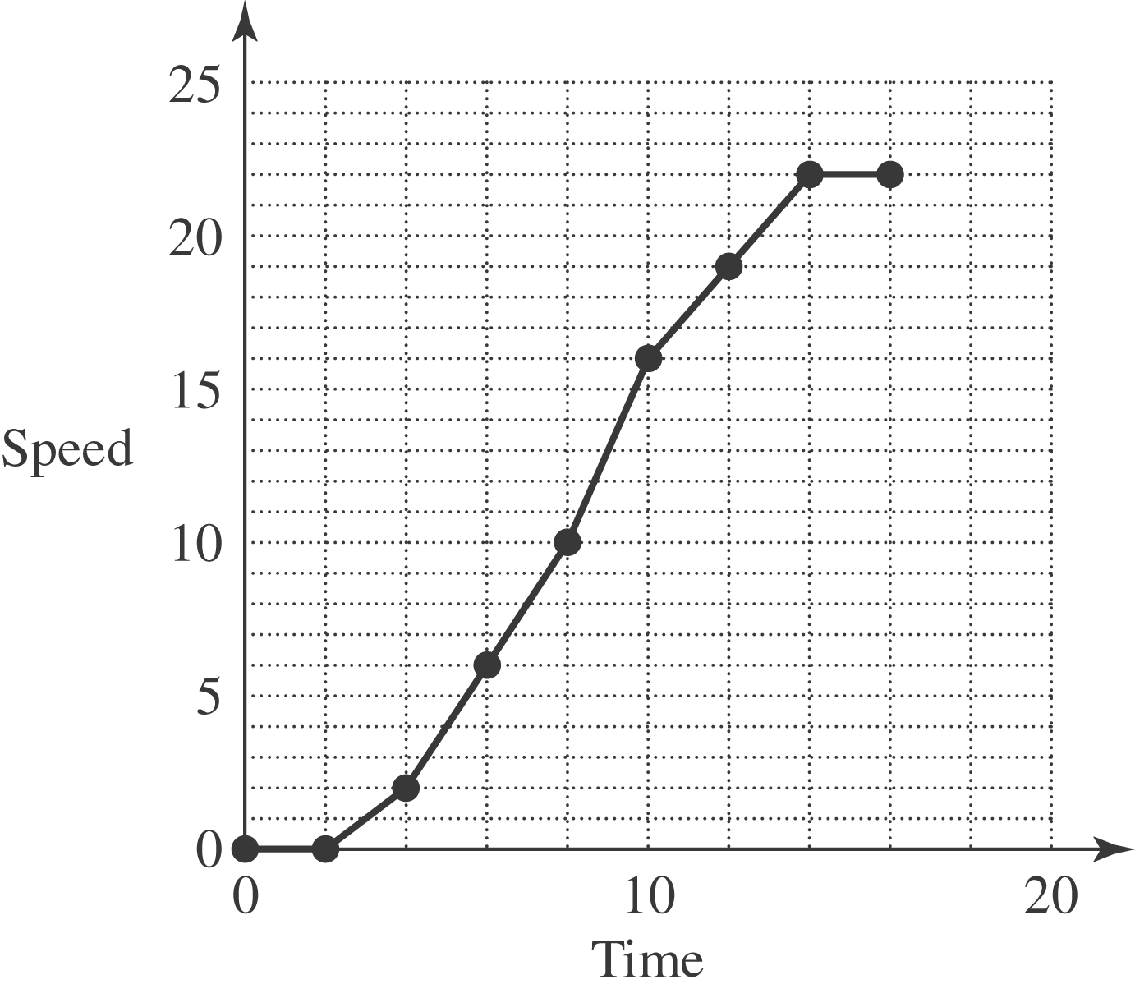

At

